

Attendance Policy

September 2025

Due for Review: Autumn Term 2026

Subject | Page
Policy
- Contact details and Introduction | 3
- Purpose | 3
- Scope and application | 4
- Legislation and guidance | 4
- Publication and availability | 4
- Definitions and interpretation | 4
- Expectations | 5
- Registers | 6
- Monitoring and improving the attendance of children with a social worker | 7
- Persistent and severe absences | 7
- Legal Intervention | 8
- Responsibilities | 8
- Monitoring attendance | 12
- Additional needs | 12
- Training | 13
- Information and sharing | 13
- Record Keeping and confidentiality | 14
Appendices
Appendix 1: DFE Attendance codes, definition and meaning | 15
Appendix 2: Admission Register | 17
Appendix 3: Attendance Registers | 18
Appendix 4: Attendance information | 20
Appendix 5: Relevant legislation, guidance and advice | 21
Appendix 6: Local arrangements | 22

Key Contact Details

School | Tiverton High School
Headteacher | Name: Nicky Lewis  Contact details: headteacher@tiverton.devon.sch.uk
SLT Attendance Champion | Name: Fay Crellen  Contact details: fcrellen@tiverton.devon.sch.uk
Attendance Officer(s) | Name: Helen Head  Contact details: attendance@tiverton.devon.sch.uk
Designated Safeguarding Lead | Name: Carrie Morrell  Contact details: cmorrell@tiverton.devon.sch.uk
School Office / Admissions / Absence Line | Name:  Contact details: admin@tiverton.devon.sch.uk

- Introduction

  - Tiverton High School (THS) recognise that it is everyone’s responsibility to support, and promote, excellent attendance and punctuality at school. BEP are committed to providing the highest quality of education to our pupils, we recognise the clear link between good attendance and the attainment of our pupils, alongside a strong, safe and happy culture of learning.

  - The law gives the right for every child of compulsory school age to a full-time education suitable to their age, aptitude, and any special educational need they may have. Where parents/carers have decided to have their child registered at school, they have a legal responsibility to ensure their child attends that school regularly. This means their child must attend school every day the school is open, except for a small number of circumstances where the child is too ill to attend, or they have been given permission for an absence in advance from the school.

  - This policy details how schools work in partnership with pupils, parents, and relevant external support agencies, to remove any barriers to attendance. This is done through building strong relationships and working collaboratively.

- Purpose

  - The purpose of this policy is to enable all schools to provide a consistent approach to improving attendance. Adopting a whole school approach ensures that all members of the school community understand the important contribution they make to:

- promoting good attendance and reducing absence, including persistent absence, by effectively removing the barriers to attendance
- ensuring every pupil has access to full-time education to which they are entitled
- acting early to address patterns of absence
- minimising the disruption caused by late arrivals, or non-attendance, to the quality of the education and provision for all pupils.

- Scope and application

  - This policy applies to all staff (including supply staff), trustees, governors and volunteers. It is designed to address the specific statutory obligations on schools as outlined in ‘Working Together to Improve School Attendance’ (DfE August 2024).

  - For the purposes of this policy and the procedures, we refer to Section 576 of the Education Act which defines the ‘parent’ of a pupil or young person as:
- both of their natural parents, whether they are married or not
- any person who, although they are not the natural parent, has parental responsibility for the pupil or young person, as defined in the Children Act (1989)
- any person who, although not the natural parent, has the care of the pupil or young person i.e., a person with whom the pupil lives, irrespective of their relationship to the pupil.
- Legislation and guidance

  - This policy meets the requirements of the ‘Working Together to Improve School Attendance’ guidance from the Department for Education (DfE) and refers to the DfE’s statutory guidance on school attendance parental responsibility measures.

  - Appendix 5 outlines the key legislation, guidance and advice that sets out the legal powers and duties that govern school attendance.

- Publication and availability

5.1 This policy is published on the school website and is available in hard copy on request.

5.2 A copy of the policy is available for inspection from the school office during the school day.

5.3 This policy can be made available in large print or other accessible formats if required.

- Definitions and interpretation

  - References to attendance includes punctuality and attendance for all or part of the timetabled school day.

  - References to parent or parents means the natural or adoptive parents of the pupil (irrespective of whether they are or have ever been married, with whom the pupil lives, or whether they have contact with the pupil), as well as any person who is not the natural or adoptive parent of the pupil, but who has care of, or parental responsibility for, the pupil (e.g., foster carer / legal guardian).

  - SLT Attendance Champion means the schools’ designated senior lead for attendance.

  - References to compulsory school age refers to when a child is required to attend school. This is on or after their fifth birthday. If they turn 5 between 1 January and 31 March, then they are of compulsory school age on 31 March; if they turn 5 between 1 April and 31 August, then they are of compulsory school age on 31 August. If they turn 5 between 1 September and 31 December, then they are of compulsory school age on 31 December. A child continues to be of compulsory school age until the last Friday of June in the school year that they reach sixteen.

  - References to persistent absence (PA) means when a child has an absence rate of 10% or more (i.e., attends for less than 90% of the time) and will be defined as a ‘persistent absentee’. These pupils are likely to be finding it difficult to be in school, or face significant barriers to their regular attendance, and therefore are likely to need more intensive support across a range of partners.

  - References to severe absence (SA) means when a child has an absence rate of 50% or more (i.e., attends for less than 50% of the time) and will be defined as a ‘severe absentee’. These severely absent pupils may find it more difficult to be in school or face bigger barriers to their regular attendance and as such are likely to need more intensive support across a range of partners.

7 Expectations

In line with DfE expectations, to manage and improve attendance effectively, all schools are expected to:

- Develop and maintain a whole school culture that promotes the benefits of high attendance.

- Have a clear school attendance policy which all staff, pupils and parents understand.

- Accurately complete attendance registers and have effective day to day processes in place to follow-up absence straight away.

- Regularly monitor and analyse attendance and absence data to identify pupils, or cohorts, that require support with their attendance and rapidly put effective strategies in place to prevent further absences and secure good attendance.

- Build strong relationships with families by listening to, and understanding, the barriers to attendance and work in partnership with families to remove them.

- Share information and work collaboratively with relevant local partners, particularly local authorities, when absence is at risk of becoming persistent or severe.

- Work with key partners to:
Expect: Aspire to high standards of attendance from all pupils and parents and build a culture where all can, and want to, be in school and ready to learn by prioritising attendance improvement across the school.

Monitor: Rigorously use attendance data to identify patterns of poor attendance (at individual and cohort level) as soon as possible so all parties can work together to resolve them before they become entrenched.

Listen and understand: When a pattern is spotted, discuss with pupils and parents to listen to and understand barriers to attendance and agree how all partners can work together to resolve them.

Facilitate support: Remove barriers in school and help pupils and parents to access the support they need to overcome the barriers outside of school. This might include an early help or whole family plan where absence is a symptom of wider issues.

Formalise support: Where absence persists and voluntary support is not working or not being engaged with, partners should work together to explain the consequences clearly and ensure support is also in place to enable families to respond. Depending on the circumstances this may include formalising support through an attendance contract or education supervision order.

Enforce: Where all other avenues have been exhausted and support is not working or not being engaged with, enforce attendance through statutory intervention: a penalty notice in line with the National Framework or prosecution to protect the pupil’s right to an education.

Taken from DfE’s ‘Working Together to Improve Attendance (section 14 page 10)

8 Registers

8.1 In line with DfE requirements, school leaders must ensure the register is taken at the start of each morning session of each school day and once during each afternoon session (see appendix 6 for exact times). On each occasion there must be a record of whether every pupil is present, attending an approved educational activity, absent, or unable to attend due to exceptional circumstance.

8.2 School leaders are expected to ensure that:

- registers are kept up to date
- register closing times are specified and adhered to
- registers are accurately completed using attendance and absence codes as defined by the DfE’s statutory guidance Working Together to Improve School Attendance (August 2024). See Appendix 1.
- there are effective day to day processes in place to follow-up all absence quickly.

9 Monitoring and improving the attendance of children with a social worker

9.1 In addition to the benefits for all pupils, good attendance at school also provides an additional safeguarding for vulnerable pupils. Historically, the national absence rates for children who have ever needed a social worker are of particular concern.

9.2 Tiverton High School will work in partnership with Local Authority and Virtual School Headteachers and, are expected to inform a child’s social worker if there are unexplained or unexpected absences from school.

10 Persistent and Severe absence

10.1 The most important elements to improving attendance are the everyday strategies to develop a culture of high expectations of attendance and punctuality, and the work with families to prevent absence becoming a concern.

10.2 Schools are expected to implement bespoke strategies to improve the attendance of pupils at risk of ‘persistent’ or ‘severe’ absence. Refer to 6.5 and 6.6 for definitions.

10.3 Any pupils who are persistently or severely absent will be closely monitored at both a school and trust level. In line with DfE’s statutory guidance, schools are expected to provide information to local partners so that pupils who need targeted attendance support receive it as quickly as possible. This is explained further in figure 1 below:

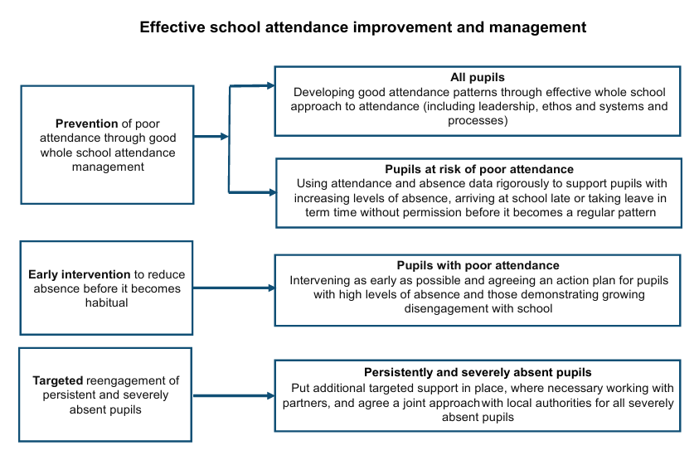

Figure 1: Taken from DfE’s Working together to improve school attendance (page 46)

11 Legal Intervention

11.1 Where all voluntary support options are unsuccessful, or are not appropriate (e.g., an unauthorised holiday in term-time), the relevant Local Authority will take forward legal intervention to formalise support and/or enforce attendance.

11.2 In line with DfE’s statutory guidance, if informal support is not successful or engaged with, the law protects pupils’ right to an education and provides a range of legal interventions to formalise attendance improvement efforts, and where all other avenues have been exhausted, it will be reinforced through prosecution, as outlined in figure 2 below:

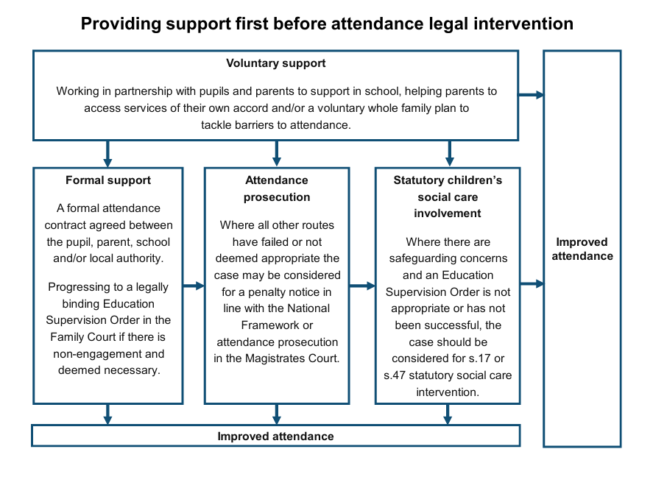
Figure 2: Taken from DfE’s Working together to improve school attendance (page 47)

11.3 Whilst it is the local authority’s responsibility to take forward ‘parenting contracts’, ‘supervision orders’ or ‘prosecutions’, schools must work closely with the local authority’s School Attendance Support Team to provide appropriate information.

11.4 School leaders are also expected to be familiar with their local authority arrangements so that they can be clear with families, where appropriate, about the process so that this route is avoided wherever possible.

12 Responsibilities

12.1 The Trustees have overall responsibility for all matters which are the subject of this policy.

12.2 The Trust Board is aware of its duties under the Equality Act 2010 and the requirement under Section 149 of the Equality Act 2010 to meet the Public Sector Equality Duty. This means in carrying out its functions, the Trustees are required to have due regard to the need to:

- eliminate discrimination and other conduct that is prohibited by the Act
- advance equality of opportunity between people who share a protected characteristic and people who do not share it
- foster good relations across all characteristics - between people who share a protected characteristic and people who do not share it
- recognise that improving attendance is a school leadership issue and appoint a designated senior leader to have overall responsibility for championing and improving attendance in school.

12.3 The School is responsible for implementing this policy in full.

12.4 A summary of responsibilities for Trustees, Governing Committees, staff, parents and pupils are outlined below:

Role | Responsibilities
Trustees | - To promote the importance of school attendance.  - To ensure that in each school there is a senior member of staff of the school leadership team appointed as the SLT Attendance Champion to have overall responsibility for championing and improving attendance in school.  - Work with Trust leaders to identify areas of focus for improvement.  - Monitor the impact of school-wide attendance efforts, including any specific strategies implemented.
Local Governing Committees | - To ensure that schools have an Attendance Champion who is a member of the SLT.  - To receive reports and monitor the impact of strategies to improve attendance.  - To ensure that support for attendance, and improving attendance, is appropriately resourced, including, where applicable, through the effective use of pupil premium funding.
Director of Student Support | - To ensure that the school leadership team:  - Fulfil their statutory duties in respect of school attendance, including support and challenge around the trends or areas identified as needing to improve.  - Receive regular training to discharge their duties in respect of attendance.  - To regularly review the data and reports provided by the schools to identify patterns in attendance, and common issues, and barriers, to pupils attending school using appropriate comparators including data from local authority area, region and nationally.  - To identify patterns in attendance and common issues and barriers to pupils attending school to ensure that effective practice can be shared across schools within the Trust.  - To report on the impact of Trust and school attendance improvement strategies to Trustees.
SLT Champion | - To lead on and embed a whole school culture that promotes the benefits of high attendance, ensuring attendance is everyone’s’ responsibility.  - To formulate a clear vision and strategy for attendance and drive improvement.  - To evaluate and monitor the impact of the attendance strategy, expectations and school processes (further details can be found in section 13).  - To have oversight of, and regularly analyse, attendance data to identify trends/patterns and ensure rapid and robust intervention is in place to secure good attendance.  - To communicate clear messages on the importance of attendance to staff, pupils, and parents/carers.  - To ensure whole school attendance is a standing agenda item in weekly SLT meetings.
Staff with specific responsibilities for attendance | - To follow the attendance policy and re-enforce expectations through interaction and communication with pupil and families.  - To establish a formal routine for registers being taken accurately each morning and afternoon.  - To ensure that all registers are completed accurately and on time every lesson, every day.  - Seek explanations of absences required from pupils, parent/carers and provide support, advice and guidance where required.  - To make enquiries about unexplained absences, including those within the school day, and follow up with pupils and parent/carers to ensure that an explanation has been formally given to the school. This may be through home visits if the school are unable to contact the parent/carers or if a reason for absence has not been provided.  - Inform the SLT Attendance Champion of any known future absences for pupils.  - To deal with lateness to lessons consistently and promptly through robust tracking of registers and inform SLT Attendance Champion of any specific concerns.  - To discuss non-attendance and / or lateness with pupils and parents (where possible) and emphasise the importance of punctuality.
All staff | - Understand the importance of good attendance and punctuality.  - Provide consistent communication to pupils and parents about attendance and punctuality.
Parents | - Ensure their child attends school on time every day and remains in school for the duration of the school day.  - Notify the school of any absence or lateness as soon as reasonably possible in accordance with this policy and when doing so, give an accurate explanation for this.  - Understand that any appointments where possible need to be made for out of school hours to avoid their child missing any learning (we recognise that orthodontic appointments, specialist medical appointments and hospital appointments cannot always be moved to out of school hours but request that attempts are made).  - Notify the school of any planned absence in advance and understand that this would be approved for exceptional circumstances only. This is in line with the Department for Education guidance which states that holidays and other leave of absence should not be taken during term time unless there are exceptional circumstances. Exceptional circumstances are a matter of discretion of the Headteacher. All cases would be judged on a case-by-case basis.  - Work with the school to explore barriers to attendance and to improve it where attendance has been raised as an issue.  - Read this policy at the start of each new school year and when any changes are made.
Pupils | Understand that:  - Staff want every pupil who attends their school to do their best and so have high expectations about attendance.  - They are expected to attend school, on time each school day.  - They are expected to attend all timetabled lessons on time.  - They should not leave a lesson or the school site without permission.  - The school has systems in place to reward good attendance and manage poor attendance.  - They should engage with the school’s arrangements for recording and managing attendance as set out in this policy.  - Any unexplained absence will be followed up. Persistent or severe lateness or non-attendance will result in action being taken by the school and may take the form of:  - offers of support to seek to identify and address any barriers to attendance.  - communication with parents/carers.  - reporting to other agencies such as children's social care.  - Escalation of cases to the local authority which may lead to formal support or attendance prosecution.  - If pupils are having difficulties that might discourage or prevent them from attending school or specific lessons regularly, they should speak to the school via their class teacher/tutor, or pastoral/safeguarding team. Pupils are entitled to expect this information to be managed sensitively.

13 Monitoring Attendance

The law entitles every child of compulsory school age to an efficient, full-time education suitable to their age, aptitude, and any special educational need they may have.

The school will accurately complete admission and attendance registers and have effective day to day processes in place to follow-up absence. Contact details of relevant staff can be found at the front of the policy.

The school will undertake regular data analysis to identify and provide additional support to pupils or pupil cohorts that need it, and to look at historic and emerging patterns across the school and develop strategies to address them.

It is the legal responsibility of every parent/carer to make sure their child receives that education. Where frequent sporadic illness occurs without sufficient justification in relation to health, the school will challenge the veracity of the illness and request that medical evidence be provided by the parent to authorise the absence (I code).

The school will:

13.1 monitor and analyse weekly attendance patterns and trends and deliver intervention and support in a targeted way to pupils and families.

13.2 use this analysis to provide regular attendance reports to class teachers to facilitate discussions with pupils and leaders (including the special educational needs coordinator and designated safeguarding lead).

13.3 conduct thorough analysis of half-termly, termly, and full year data to identify patterns and trends.

13.4 effectively communicate attendance concerns with pupils, parents and carers and work with them to remove any barriers.

13.5 benchmark attendance data at whole school, year group and cohort level to identify areas of focus for improvement.

13.6 devise specific strategies to address areas of poor attendance identified through data considering any reasonable adjustments that may be required to support students with special educational needs or mental health or well-being concerns.

13.7 monitor the impact of school-wide attendance efforts, including any specific strategies implemented.

13.8 provide data and reports to the Trust to support attendance efforts and impact.

14 Additional needs

14.1 The school recognises that some pupils may find it harder than others to attend school and will work with those pupils and parents/carers to try to remove barriers to attendance by building strong and trusting relationships and working together to put the right support in place.

14.2 The school will make reasonable adjustments where a pupil has a disability that affects their ability to attend school regularly. These may include considering support or reasonable adjustments for transport, routines, access to support in school and lunchtime arrangements, and / or time limited phased returns.

14.3 The school will work with parents to develop specific support approaches for attendance for pupils with special educational needs and disabilities and medical conditions as appropriate e.g., ensuring the provision outlined in a pupil’s education, health and care plan is accessed.

14.4 Where barriers are outside of the school's control, the school will work with parents, pupils, and external agencies and partners to identify alternative sources of support or consider, where appropriate, making a referral for early help.

15 Training

15.1 The school will ensure that regular guidance and training about attendance is arranged on induction and at regular intervals thereafter, so that all staff and volunteers understand what is expected of them by this policy and have the necessary knowledge and skills to carry out their roles.

As a minimum this will include all staff understanding:

- the law and requirements of schools including keeping accurate registers.
- the importance of good attendance
- that absence is always a symptom of wider circumstances.
- the school's strategies and procedures for tracking, following up and improving attendance.

15.2 Dedicated attendance training is provided to any member of staff with a specified attendance function in their role, including administrative, pastoral, or family support staff and senior leaders.

As a minimum this will include

- the law and requirements of schools including keeping accurate registers
- the process for working with other partners to provide more intensive support to pupils who need it
- the necessary skills to interpret and analyse attendance data
- any additional training that would be beneficial to support pupils and pupil cohorts to overcome commonly seen barriers to attendance.

16 Information and sharing

16.1 Personal information on attendance will only be shared in line with legal obligations and regard to Government guidance on attendance, safeguarding and children missing education.

17 Record keeping and confidentiality

17.1 All records created in accordance with this policy are managed in accordance with the school's policies that apply to the retention and destruction of records.

17.2 The information created in connection with this policy may contain personal data. The school's use of this personal data will be in accordance with data protection law. The school has published privacy notices on its website which explains how the school will use personal data.

APPENDICIES

Appendix 1: DFE Attendance Codes, Descriptions and Meaning
Appendix 2: Admission register
Appendix 3: Attendance register
Appendix 4: Attendance Information Sheet for parents and carers
Appendix 5: Legislation, guidance and advice
Appendix 6: Local school arrangements

Appendix 1

- DFE Attendance Codes, Descriptions and Meaning

CODE | DESCRIPTION | MEANING | FOR STATISTICAL PURPOSES
/ | Present at the school (AM) | Present
\ | Present at the school (PM) | Present
B | Attending any other approved educational activity | Approved Education Activity | Counted as physically  present
C1 | Leave of absence for the purpose of participating in a regulated performance or undertaking regulated employment abroad | Authorised absence
C2 | Leave of absence for a compulsory school age pupil subject to a part-time timetable | Authorised absence
D | Dual registered at another school | Approved Education Activity | Counted as physically  present
E | Suspended or permanently excluded and no alternative provision made | Authorised absence
G | Holiday not granted by the school | Unauthorised absence
I | Illness (not medical or dental appointment) | Authorised absence
K | Attending education provision arranged by the local authority | Approved Education Activity | Counted as physically  present
J1 | Leave of absence for the purpose of attending an interview for employment or for admission to another educational institution | Approved Education Activity | Counted as physically  present
L | Late arrival before the register is closed | Present
M | Leave of absence for the purpose of attending a medical or dental appointment | Authorised absence
N | Reason for absence not yet established | Unauthorised absence
O | Absent in other or unknown circumstances | Unauthorised absence
P | Participating in a sporting activity | Approved Education Activity | Counted as physically  present
Q | Unable to attend the school because of a lack of access arrangements
R | Religious observance | Authorised absence
S | Leave of absence for the purpose of studying for a public examination | Authorised absence
T | Parent travelling for occupational purposes | Authorised absence
U | Arrived in school after registration closed | Unauthorised absence
V | Attending an educational visit or trip | Approved Education Activity | Counted as physically  present
W | Attending work experience | Approved Education Activity | Counted as physically  present
X | Non-compulsory school age pupil not required to attend school | Not counted in possible attendances
Y1 | Unable to attend due to transport normally provided not being available | Not counted in possible attendances
Y2 | Unable to attend due to widespread disruption to travel | Not counted in possible attendances
Y3 | Unable to attend due to part of the school premises being closed | Not counted in possible attendances
Y4 | Unable to attend due to the whole school site being unexpectedly closed | Not counted in possible attendances
Y5 | Unable to attend as pupil is in criminal justice detention | Not counted in possible attendances
Y6 | Unable to attend in accordance with public health guidance or law | Not counted in possible attendances
Y7 | Unable to attend because of any other unavoidable cause | Not counted in possible attendances
Z | Prospective pupil not on admission register | Not counted in possible attendances
# | Planned whole school closure | Not counted in possible attendances

See Chapter 8: Working together to improve school attendance (applies from 19 August 2024) (publishing.service.gov.uk)

Appendix 2

- Admission register

  - In accordance with the requirements of the Education (Pupil Registration) (England) Regulations 2006 (as amended), the school will:

- maintain an admission register of pupils admitted to the school (also known as the school roll); and

- inform the local authority of any pupil who is going to be added to or deleted from the schools’ admission register at non-standard transition points.

  - The admissions register contains specific personal details of every pupil in the school, including their date of admission, information regarding parents and carers and details of the school they last attended.

  - The school will not 'off-roll' pupils, that is, it will not remove a pupil from the school roll without a formal, permanent exclusion or by encouraging a parent to remove their child from the school roll, when the removal would be primarily in the interests of the school rather than in the best interests of the pupil.

  - Where the school notifies the local authority that the pupil's name is to be deleted from the admission register, the school must provide the following information:

- the full name of the pupil
- the full name and address of any parent with whom the pupil lives
- at least one telephone number of any parent with whom the pupil lives
- the full name and address of the parent who the pupil is going to live with, and the date the pupil is expected to start living there, if applicable
- name of the pupil's other or future school and pupil's start date or expected start date there, if applicable
- the grounds (set out in regulation 9 (1) or (3) under which the pupil's name is to be deleted from the admission register.

Appendix 3

- Attendance register

1.1 Attendance of compulsory school-aged pupils is recorded and monitored in accordance with the statutory requirements and the school has adopted the national codes system to enable it to monitor attendance and absence in a consistent way which complies with the regulations.

1.2 The attendance of non-compulsory school age will be recorded in the same way so that attendance can be monitored, unexplained absences are investigated, and the school can ensure their safety and welfare.

1.3 The school will use these records to identify patterns of poor attendance (at individual and cohort level) and work with pupils and parents to resolve any issues before they become entrenched.

1.4 The school is required by law to take attendance registers twice daily - once at the start of the morning session and once during the afternoon session.

1.5 On each occasion it will be recorded whether every pupil is:

    - present
    - absent
    - attending an approved educational activity
    - unable to attend school due to an exceptional circumstance

- Recording absences

2.1 Absence will be recorded as set out in 3 and 5 below using national absence codes correlating to:

- authorised absence
- excluded (while still on the admission register)
- holiday authorised by the school
- illness
- medical or dental appointments
- religious observance
- study leave
- Gypsy, Roma, and Traveller absence

- Absence from school

3.1 All applications for authorised absence from school should be made with reasonable notice and addressed to the Headteacher.

3.2 Only exceptional circumstances will warrant an authorised leave of absence. The school will consider each application for authorised absence individually considering the specific facts and circumstances and the relevant background context behind the request.

3.3 If a leave of absence is granted, it is for the Headteacher to determine the length of time the pupil is authorised to be away from school.

3.4 Absence will usually be authorised for religious observance if the day concerned is exclusively set apart for religious observance by the religious body to which parents and pupils belong. Parents are expected to make a request for this type of leave of absence in advance.

- Remote education

4.1 The school is required to record all absence from in-person lessons.

4.2 The school may, in limited circumstances, provide remote education to enable pupils, who are well enough to learn but unable to attend the school site, to keep pace with their education.

4.3 The school must ensure pupils accessing remote education are marked as absent on the register using the most appropriate absent code (paragraph 311 in ‘Working Together to Improve School Attendance’ 2024). Separate records will be maintained to monitor a pupil's engagement with this activity and plans for their reintegration to class.

- Unauthorised absence

5.1 The "unauthorised absence" code will be used when prior permission for absence has not been given. It will also be used where the school is not satisfied with the explanation given for absence, or delayed attendance, meaning that the code for "unable to attend due to an exceptional circumstance" is not appropriate.

Examples include:

- A holiday that has not been authorised or is more than the period determined by the Headteacher.
- The reason for absence has not been provided.
- A pupil is absent from school without authorisation.
- A pupil has arrived in school after registration has closed and without reasonable explanation.
- Frequent sporadic illness without sufficient justification in relation to health.

Appendix 4

Attendance Information Sheet for parents and carers

Missing lessons makes it hard to catch up and students need to work harder when they come back. Pupils attend school for 190 days per year; there are 175 non-school days a year for holiday, cultural experiences and family time. Any child with attendance of 90% or below is classed as a persistent absentee (PA) by the Government. Every school is required to take action to work with families to improve attendance. It is useful for you to know what attendance figures mean for your child.

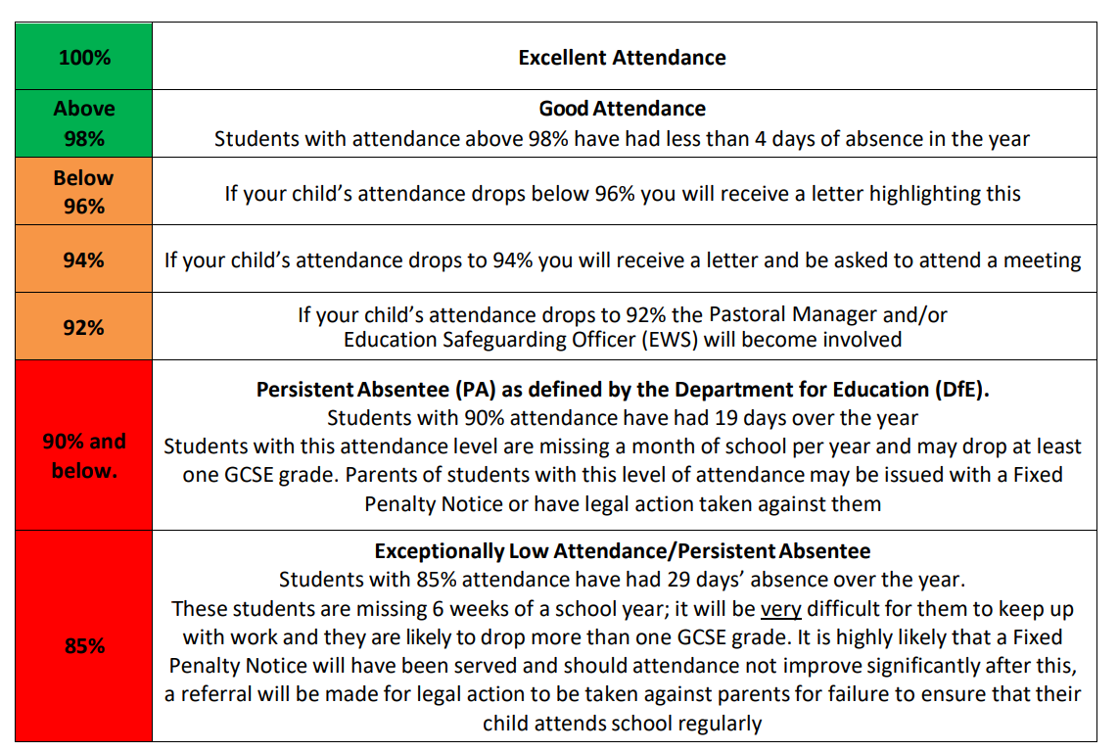

Reporting an Absence:

- All absences must be reported by the required time identified in appendix 6 below (and on each subsequent day) by either calling the absence line or emailing the relevant school.
- If you know your child is going to be absent, please let us know in advance. If your child has been absent due to a medical appointment, please attach or email in a copy of the appointment card/hospital letter.
- Medical evidence may be required where clarification is needed to accurately record absence in the attendance register. Where the school has genuine and reasonable doubt about the authenticity of the illness medical evidence may be requested to support the absence.

Punctuality

Arriving late to school and into lesson is very disruptive for the teacher and other class members. It also means that late student themselves miss important input from teachers.

Appendix 5

Legislation, guidance and advice

This policy has regard to the following legislation, guidance and advice:

- Working together to improve school attendance (DfE, August 2024).
- Education (Independent School Standards) Regulations 2014
- Statutory framework for the Early Years Foundation Stage (DfE, March 2021)
- The Education Acts 1996 and 2002
- The Children Act 1989
- Education (Pupil Registration Regulations) 2006
- The School Attendance (Pupil Registration) (England) Regulations 2024
- The Education (Parenting Contracts and Parenting Orders) (England) Regulations 2007
- The Education (Penalty Notices) (England) Regulations 2007, as amended
- The Education (Information about Individual Pupils) (England) Regulations 2013
- The Children and Young Persons Acts 1933 and 1963 The Equality Act 2010
- Equality Act 2010; and Data Protection Act 2018 and UK General Data Protection Regulation (UK GDPR)
- The Education and Inspections Act 2006
- Keeping children safe in education (DfE, September 2024)
- School behaviour and attendance: parental responsibility measures (DfE, May 2020)
- Children missing education (DfE, September 2016)
- Supporting pupils with medical conditions at school (DfE, August 2017)
- Behaviour in schools: advice for headteachers and school staff (DfE, September 2022)
- Remote education guidance (DfE, October 2022)
- School suspensions and permanent exclusions (DfE, September 2023)
- SEND Code of practice: 0 to 25 years (DfE and Department of Health, January 2015).

Appendix 6
Part 1: Local Arrangements: Schools to add relevant details

School times:
The school gates are open from 8 am and we expect all pupils to be on site by 8.30 am ready for the start if the day.
The school day starts at 8.35am and all pupils should be in their classroom at this time.
The first (morning) registration session starts at 8.35 am
Pupils will receive a late mark if they are not in their designated classroom by 8.35 am.
The register closes at: 8.55 am
Attendance after the register closes will receive a mark to show that the pupil is on site, (U) but will count as an absent mark. Pupils arriving late after 8.35 am should report to the late room where they will be signed in. Those arriving after 8.55 am should report to the main school office and sign in with the attendance officer.
The second (afternoon) registration session starts at 12.15 pm

Absence reporting:
Parents/carers must contact the attendance officer via email attendance@tiverton.devon.sch.uk or phone 01884 256655 to notify the school of any absence or lateness and, when doing so, give an accurate explanation for the absence.
Parents are expected to contact the school by 8.30 am providing the reason for absence and when their pupil will be returning to school.

The school will follow up any absences to ascertain the reason if we do not receive one.
Unexplained absences will be followed up on the morning of the first day of unexplained absence and the school will identify whether the absence is approved or not.
The school will contact parents and/or other listed emergency contacts where no contact has been made. Where required, we may conduct reasonable enquiries with friends or neighbours and will carry out welfare home visits as necessary. If no contact is made, we may request a welfare check from the police.

In the case where the reason for absence cannot be ascertained by the school and no reason has been issued for the pupil’s absence, the school will initiate safeguarding procedures and the DSL will decide on the best course of action to ensure the safety of the pupil, following procedures for children missing in education as outlined in the document from the Department of Education. Any pupils who fail to attend regularly or who are absent for more than one week will be referred to Carrie Morrell (DSL) and Fay Crellen (Deputy Headteacher/SLT Champion).

The school will identify the correct code to use and will input it as soon as the reason for absence in ascertained. This will take no longer than 5 working days after the session.

If a pupil needs to leave school during the day, they must sign out at the main reception with a parent once authorisation has been given.

To request a ‘Leave of Absence’ parents are requested to complete an absence request form (S2 Form). This can be accessed via Contact - Tiverton High School and clicking on the attendance tab.

Pupils educated off-site are monitored daily for their attendance at the off-site/alternative provision.
Staff work closely with the staff at the off-site provision, the pupil, and their parents to support the pupil to maintain good attendance.

If parents/carers would like more detailed support about attendance please contact your child’s Tutor or Head of year (HoY)

Part 2: School strategy

Our vision for attendance is:
At THS we know that regular attendance is essential for students to feel a sense of belonging to our school community, this is so they can achieve the best outcomes they are capable of. Fostering a culture of belonging involves creating a warm welcoming environment, promoting inclusivity, and recognising individual needs. Only by attending school regularly, will our students be able to take full advantage of the educational opportunities available to them. High levels of attainment depend on high attendance. The whole school community; students, parents, carers, teachers, support staff and school governors, all have a responsibility for ensuring good school attendance, and we all have important roles to play.

Our strategy is underpinned by the DFE ‘Working Together to Improve School Attendance guidance’. This document emphasises that ‘improving attendance is everyone’s business.’ We work together to teach our students that attendance is fundamental to personal success. The DfE guidance emphasises that ‘successfully treating the root causes of absence and removing barriers to attendance, at home, in school or more broadly requires schools and local partners to work collaboratively with, not against families.’

Attendance and punctuality is a key strategic priority for our school, therefore we aim to ensure that we:
- Create a strong classroom and school culture where teachers and support staff purposefully develop relationships with students
- Regularly monitor attendance so that we can quickly follow up on poor attendance, and that we develop a systematic approach to gathering and analysing attendance data.
- Remove barriers that exist for students attending school regularly by providing appropriate support
- Encourage participation by creating opportunities for students to engage meaningfully in their learning and enrichment
- Maintain a culture of high expectations and respect by ensuring that adults model respect and empathy while holding firm boundaries.
- Collaborate with parents and students and work in partnership to improve students’ attendance at school.
- Adopt an inclusive attendance model that embeds our whole school responsibility for promoting a positive attitude towards attendance and punctuality.

Our targets for attendance are:
- Overall attendance: Aspirational target 95% end of academic year 2027/28. End of academic year 2025/26 - 90%
- Reduce persistent absence to 25%
- Reduce Severely Absence to 4%
- SEND 90%
- SEND/PP 90%

We will communicate our vision and targets to staff, pupils, families and other stakeholders.
We communicate this to our school community via:
- Newsletters
- The school website
- School events and open days
- Social media accounts
- Emails
- Phone calls and home visits
- Attendance policy
- Assemblies and tutor time

We recognise that absence from school can pose a safeguarding risk for our pupils. We will make sure that our staff, pupils and families understand these risks by:
- Phone calls and home visits
- Information leaflets
- Workshops to raise awareness
- Targeted support
- Briefings by the designated safeguarding lead (DSL) SLT champion orother appropriate staff members
- Information shared in assemblies and tutor time
- Reduced timetable procedures

We expect good attendance and punctuality from our pupils. We use the following strategies to ensure that pupils understand this expectation:
- Phone calls and home visits
- Rewards and incentives for good and improved attendance
- Emails to parents to celebrate good attendance and improvement in attendance
- Reminders and updates in assemblies and tutor time
- Pastoral support for students with poor attendance
- Personal attendance improvement plans

We empower staff to take responsibility for attendance by:
- Offering relevant training to help staff to promote good attendance
- Sharing relevant data so that they know which groups are most at risk of poor attendance
- Encouraging Head of Year’s to discuss attendance with tutors/class teachers who will then talk to their students about attendance
- Having a ‘rewards focus’ in assemblies and tutor time.
- Prioritising student focus meetings lead by the Head of Year
- Enabling staff to chat informally with parents/carers about attendance

We recognise that attendance is an important area of school improvement. We demonstrate our commitment to this by making sure it is resourced appropriately, to create, build and maintain systems to promote good attendance.

We do this by:
- Allocating dedicated staff time to monitor, support, and intervene in attendance matters.
- Using data systems such as Bromcom and Class Charts to track attendance patterns and identify concerns early.
- Working closely with families to understand barriers to attendance and offer appropriate support.
- Celebrating good attendance through recognition systems like Proud Points and tutor praise.
- Embedding attendance into our culture, linking it to our core values: Work Hard, Be Kind, Belong.
- Providing targeted interventions for students with persistent absence, including personalised support plans.
- Collaborating with external agencies when needed to address complex attendance issues.
- Ensuring staff are trained to understand the importance of attendance and how to promote it positively.
We ensure that our staff are trained to use our attendance systems effectively and promote good attendance in school.

Examples of the training offered to our staff include:
- Whole School training on INSET Day
- Drip feed attendance updates weekly
- Attendance updates during briefings, year meetings, subject meetings
- Attendance Officer network meeting.
- Induction meetings
- Ongoing CPD
- Regular meetings and line management.
- Weekly updates via year leaders

We ensure that our governors have an accurate view of attendance at our school so that they can offer effective support and challenge. We keep governors informed by:
- Headteacher’s reports
- Termly attendance updates in meetings
- Governor scrutiny of attendance data
- Link governor visits.

As a school, we understand that developing a welcoming and positive culture is important in building trust and engagement and therefore promoting good attendance. We do this by:
- Offering a wide range of extracurricular activities so that students can build better relationships with staff
- Ensuring that strong pastoral systems are in place so that students and families are supported when needed
- Organising a range of social events for parents to build a sense of community
- Ensuring that staff phone families with positive news, rather than only contacting them when there is a problem.

We strive to communicate effectively with staff, pupils and families so that they understand what to expect and what is expected of them.

Our strategies for doing this include:
- Attendance process flow chart
- Written communications, such as letters home and information leaflets
- Online communications, such as the school website, emails and the use of social media
- Telephone contact, including welfare calls and texts to parents
- Face-to-face interactions, such as parents’ evenings, information sessions and parenting workshops
- Use of a strategic calendar

When required, we work with partners to promote good attendance.
Examples include:
- 0-25 Team
- Inclusion team
- Attendance improvement team
- Social workers
- FIT/FSW
- Education Key Workers
- Virtual school
- Early Help

We strive to model respectful relationships and appropriate communication for staff and pupils. This will help relationships between pupils and staff to reflect a positive and respectful culture.
All staff members will:
- Treat students with dignity, build relationships rooted in mutual respect and observe proper boundaries
- Take into consideration the vulnerability of some students and the ways in which this might contribute to absence, handling confidential information sensitively
- Understand the importance of school as a place of safety where students can enjoy trusted relationships with staff and students, particularly for children with a social worker and those who have experienced adversity
- Communicate effectively with families regarding students’ attendance and wellbeing.

Parents and carers are expected to:
- Treat staff with respect
- Actively support the work of the school
- Ask staff for support when this is needed
- Let us know as soon as possible when there are issues which may affect absence
- Support home visits

We communicate this expectation by:
- Developing an Attendance support plan if attendance becomes a concern
- Having a dedicated attendance phone number/email address
- Making it easy to contact school when there is an issue
- Providing a designated contact for families that need extra support

We use clear and consistently applied systems and processes to improve, reward and incentivise attendance and to address absences.

Our systems include:
- Following the attendance monitoring flow chart
- Postcards/emails/letters home
- School Website
- Social media
- Assembly recognition
- Celebration breakfasts
- House points for 100% attendance
- Improved attendance recognitions
- Golden Tickets

We use robust school systems to provide useful data at cohort, group and individual levels to give an accurate view of attendance, reasons for absence and patterns amongst groups. These groups include:
- Children who are disadvantaged
- Children who have a social worker, including looked-after children
- Young carers
- Children who are eligible for free school meals
- Children who speak English as an Additional Language (EAL)
- Children who have Special Educational Needs and/or Disabilities (SEND)

We analyse attendance data regularly to identify issues and facilitate early intervention. This includes raising concerns with partner agencies that work with families.
- Assessing the individual pupil’s barrier/s to school attendance.
- Planning what level of support the pupil needs – specialised, targeted or universal.
- Implementing and supporting the pupil (and their family) with the plan.
- Monitoring and reviewing every pupil's attendance to school

Every member of staff in our school has a role in promoting good attendance. We help staff to know and understand this responsibility by:

- Making specific reference to attendance in staff roles and responsibilities descriptions
- Talking about attendance during line management meetings
- Discussing attendance issues during staff meetings
- HoY/tutor meetings set agenda item.

